 | 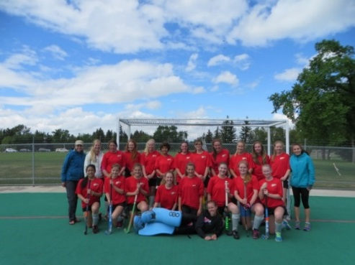
CJP/ Junior Leagues – Ages 9-17 (co-ed) www.fieldhockey.ab.ca

Calgary Junior Field Hockey Program (CJP) Fall OUTDOOR Registration is Open
There is one practice a week, followed by weekly 11 vs. 11 games. Beginners welcome!
- Astros Club Practices will be on Tuesday nights for Fall CJP OUTDOOR League
  - U12/U14 from 6:15pm – 7:30pm … U18 from 7:30pm – 8:30pm
- Games will be on Sundays at the University of Calgary (Hawkings Field) or Ernest Manning Turf Field
- U12/U14 League: http://fieldhockey.ab.ca/get-involved/register/2816-2/
- U18 League: http://fieldhockey.ab.ca/get-involved/register/u18-fall-league-registration-2017/

Astros Field Hockey Club
www.astrosfieldhockey.com
email: astrosfh@telusplanet.net

Astros INDOOR Practices (Sept 18 – Dec 6, Jan 15 – April 4): Mondays, 6:30pm - 8:30pm @ U of C Red Gym and/or Wednesdays, 8:30pm - 10pm @ U of C Gold Gym)
- Register @ https://www.ucalgary.ca/ActiveLiving/registration/Program/1257?path=All_Field-Hockey

Astros INDOOR U18 Teams (Oct. 1 – Mar. 25): Games Saturdays, 4pm – 7pm or Sundays, 7:30am – 9:30pm @ Repsol Sport Centre
- Register @ https://www.teampages.com/forms/11087-Astros-Club-Registration-Indoor-Outdoor-Leagues

Preseason OUTDOOR Boot Camp (April): 7pm – 9pm @ Viper Dome, 2225 Crowchild Tr. NW (see Astros website for registration)

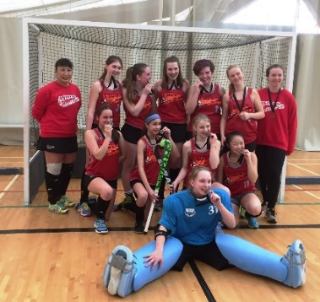  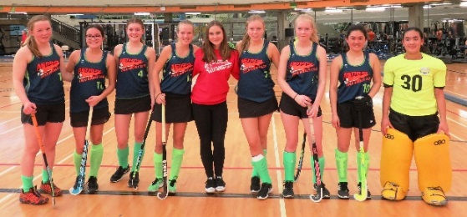 |  | Astros Field Hockey Club (Junior Teams)  - Outdoor Spring CJP U12, U14, U18 Teams  - Outdoor Fall CJP U14 and U18 Teams  - Outdoor U14/U16/U18 Touring Team (2017 BC Tour)  - Outdoor U18 Touring Team (2018 CA or BC Tour)  - Indoor Junior Teams (Spartans, Fury)  - Indoor U18 Touring Team (Tournament TBC)  Astros Field Hockey Club (Senior Teams)  *Players must be a minimum of 16 years of age  - Outdoor Ladies’ League Teams (7 Teams)  - Indoor Ladies’ League Teams (7 Teams)

