Hello Parents and Players,
Welcome to the Astros Field Hockey Club!

BACKGROUND INFO
The Calgary Junior Field Hockey Program (CJFH) is a program for children and youth who are starting or continuing their Outdoor skill development in field hockey. CJFH will continue to manage/organize programs for FunStix (ages 6 – 9).

The Astros Club will have teams in each of the U12 (coed), U14 (girls) and U16/U18 (girls) age groups. For female athletes who are not yet 16 years of age, this would be the only option to play. For athletes who are new to field hockey, this is also the best place to get started. The goal is to have Astros girls eventually join one of the senior Astros teams (three divisions) in Ladies League for outdoor once they are ready (games are played May-August). See LTAD.

REGISTRATION STEPS
- Astros U12/U14/U16 – https://www.astrosfieldhockey.com/forms/13244-Astros-Junior-Registration
- 2022-23 FHA/FHC Membership (choose 2022-23 Season) – FHA/FHC Membership and Insurance
  - If your athlete played 2022 Fall Outdoor or 2022-23 Fall/Winter Indoor, they should have this already
  - https://www.rampregistrations.com/login?v3=1052d84f
  - Valid from Sept. 1/2022 – Aug. 31/2023
  - Choose JUNIOR for U14 or U16/U18 team; choose YOUTH for U12 team
- FunStix should register on the FHA website – http://fieldhockey.ab.ca/content/funstix-programs-u8-u10

TEAMS – FORMAT AND STRUCTURE
Fine details are being finalized on the league format. When dividing the teams, we will aim to have relatively balanced teams AND try to take into consideration players who carpool or who have friends that they want to play with.

AGE GROUP | FORMAT | FIELD | GAME DURATION
Astros U12 Red/Blue | 6v6 Coed | End Zone/Qtr Field | 2 x 10 Dbl Headers or 4 x 10-Min. Qtrs
Astros U14 Red/Blue | 7v7 Girls | Half Field | 2 x 25-Minute Halves
Astros U16/U18 | 11v11 Girls | Full Field | 2 x 25-Minute Halves

ASTROS JR. PRACTICES
- For practices, players will be together in each of the respective age groups
- Practice details will be in TeamSnap
- Practices are Wednesdays and Thursdays, depending on field availability … athletes must attend one practice per week
- All outdoor practices are on artificial turf – Shouldice Athletic Park (Stampeder or Encana Field) or McMahon Stadium; last practice is June 22nd
- There may also be a couple of mini-camps/practice day + games in July

GAMES
- Please mark your player’s presence/absences for practices and games under Availability tab in TeamSnap. This will allow coaches to call up subs from our other teams.
- League games are on Sundays; details will be uploaded to TeamSnap once we get the schedule from CJFH

IMPORTANT DATES:
- April 30 – League Games commence
- May 11 – 13 – CLFHA Boot Camp + Tournament
- May 21 – Victoria Day Weekend - Off
- May 27/28 – Festival, if Lacombe, this would be @ MeGlobal Athletic Park
- June 25 – Last League games
- July – TBC Mini-camps/games

PLAYER EQUIPMENT
- Mouth Guard (mandatory) – you can get these at SportChek, etc. or a dentist
  - For safety reasons, players must have mouth guards to participate; we want to keep those teeth intact
- Shin Guards – soccer ones are fine for U12s; bigger is better for field hockey for U14s and up!
- Contact(s) to purchase field hockey equipment – sticks, shin guards, gloves, bags
  - Hamza Sohail – hamzaues@gmail.com or 587-892-7171
  - Sohail Abdullah – sohail63@gmail.com or 403-690-6195
- Water Bottle
- Running Shoes or Turf Shoes
- Dress appropriately for the weather

UNIFORMS
- Uniform kits for field players will include:
  - Reversible tank (red/white or navy/white)
  - Short sleeve shirt (red)
  - Long sleeve shirt (red)
  - U12 RED team will have red socks; U12 BLUE team will have black socks
  - U14 RED team will have red socks; U14 BLUE team will have black socks
  - U16 team will have black socks
  - Bucket hat (red)

(OPTIONAL) ASTROS TEAM GEAR AVAILABLE FOR PURCHASE
- Sweatshirts - $40 (custom order with player name on the back)
- Hoodies - $45 (custom order with player name on the back)
- Sweatpants - $35 (custom order with player name on back)
- Order Form - Astros Club Gear Order
- Payment can be made via e-Transfer to astrosfh@telusplanet.net

TOURNAMENTS / FESTIVALS
CLFHA Boot Camp and One-Day Tournament (U16s Only): May 12th and May 13th
- Boot camp is either Thurs., May 11th or Fri., May 12th from 4pm – 8pm at U of C Hawkings Field
  - Register http://www.clfha.com/forms/24361-CLFHA-U18-Girls-Boot-Camp-and-One-Day-Tournament
- Tournament is at U of C Hawkings Field

Lacombe Tournament (All Ages): Sunday, May 29th
- Tourney will start as early as 8am and run until 4pm
- Location: TBD, if in Lacombe, it would be at MeGlobal Athletic Park

VOLUNTEER BOND
Our Astros Club is volunteer based, including all the coaches and organizers. We need help from parents to make the program successful, especially now that CJFH and FHA have delegated more of the organization work to clubs.
- Parents need to provide a post-dated cheque (to June 30, 2023) for $100 as a volunteer bond for each athlete. If parents do not have cheques, the volunteer bond can be e-Transferred to astrosfh@telusplanet.net
- Please sign up for Parent Volunteer Tasks
- Some tasks are shorter and simpler in nature, so we would ask parents to sign up for 3 – 4 of the shorter/simpler tasks

VOLUNTEER TASKS (as part of $100 Volunteer Bond) Parent Volunteer Sign-Up
Parents and/or players are asked to give back to the program and volunteer!

Please bring a cheque made out to Astros Field Hockey Club for $100.00 (post-dated for June 30th) – this is a volunteer bond cheque. We are not looking at cashing these cheques, but rather getting parents to volunteer a bit.
- Please sign up for a volunteer position if you have not already done so
- Parents must sign up for 4 credits per athlete
- Please sign up for Parent Volunteer Tasks (https://www.signupgenius.com/go/10C0E4FABAC29AAF8C25-2023)

There are several ways to volunteer, including such things as:

- Coaches’ On Field Practice Assistant (4 credits)
- TeamSnap Manager (2 credits)
- Uniform Coordinator (2 credits)
- Beginning of Season Party Coordinator (4 credits)
- End of Season Party Coordinator (4 credits)
- Game Day Field Set Up / Take Down (1 credit)
- Lacombe Festival (2 credits)
- Calgary Festival (2 credits)

Field Hockey Long Term Athlete Development
Long Term Hockey Development (LTHD) recognizes these 7 stages in the development of field hockey players:
- Stage 1: Active Start: Ages 0-U6
- Stage 2: Fundamentals: Ages 6-10 (FunStix)
- Stage 3: Learning to Train: Ages 9-12 males, 8-11 females (CJFH U12s)
- Stage 4: Training to Train: Ages 12-16 males, 11-15 females (Astros U14/U16 Teams)
- Stage 5: Training to Compete: Ages 16-19 (Astros U16/U18 Teams OR Astros Ladies’ Teams)
- Stage 6: Training to Win: Ages 19 and beyond (Astros Ladies Teams)
- Stage 7: Hockey for Life: All ages (Astros Ladies Teams)

Source: http://lthd.fieldhockey.ca/en/whatisltad
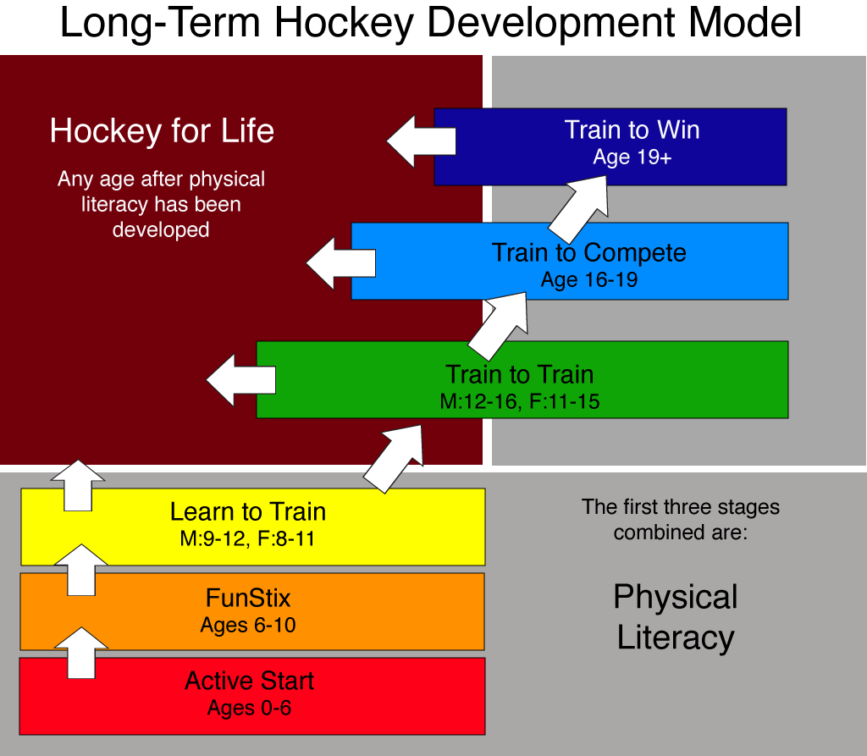

LOOKING AHEAD …
- Astros U14/U16 development camp and tour to BC (April 2023 or September 2023)
- Astros U16 development and tour to US (Spring 2024 or 2025)

Cheers,
Verla Wong, Astros Club President
astrosfh@telusplanet.net
http://astrosfieldhockey.com/

